**Name : ID:**

**Lab # 3: Implementation of Conditional Statements (A)**

**OBJECTIVES**

In this lab you will learn:

- the use of Conditional Statements

**CONDITIONAL STATEMENTS**

The fundamental conditional operation is the **if statement**. It looks something like this:

*if* *conditional expression*:

*resulting action*

* The *conditional expression* is some manner of test, for example to see if one variable is larger than another.
* The tests include = = (same as), != (not same as), >, <, >= and <=.
* The logical directives and and or are also available. The *resulting action* is any legal block of Python code. It may be a single line or a multitude of lines.
* So, if the conditional expression is true, the resulting action is performed. If the expression is not true, the action is skipped. In either case, program execution picks up at the next line after the resulting action block.
* **It is extremely** **important to note that the resulting action block must be indented.** All lines of the block must be indented by the same amount. This is how Python recognizes that it is a single block of code.

**Task 1**

a = 5

b = 8

if a > b :

print( "a is greater than b" )

if b > a :

print( "b is greater than a" )

if a == b :

print( "a is equal to b" )

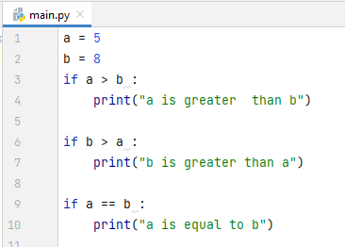

**Task 2**

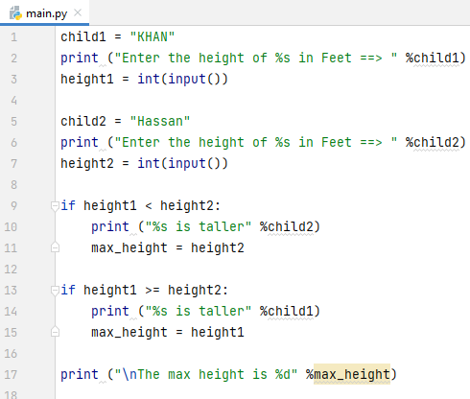

child1 = "KHAN"  
print ("Enter the height of %s in Feet ==> " %child1)  
height1 = int(input())  
  
child2 = "Hassan"  
print ("Enter the height of %s in Feet ==> " %child2)  
height2 = int(input())  
  
if height1 < height2:  
 print ("%s is taller" %child2)  
 max_height = height2  
  
if height1 >= height2:  
 print ("%s is taller" %child1)  
 max_height = height1  
  
print ("\nThe max height is %d" %max_height)

**The %s operator lets you add a value into a Python string**. The **%s** signifies that you want to add a string value into a string. The % operator can be used with other configurations, such as %d, to format different types of values.

**Task 3**

**Using If - Else**

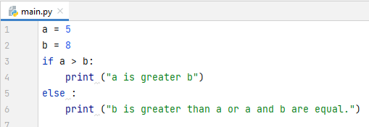

a = 5  
b = 8  
if a > b:  
 print ("a is greater b")  
else :  
 print ("b is greater than a or a and b are equal.")

**Task 4**

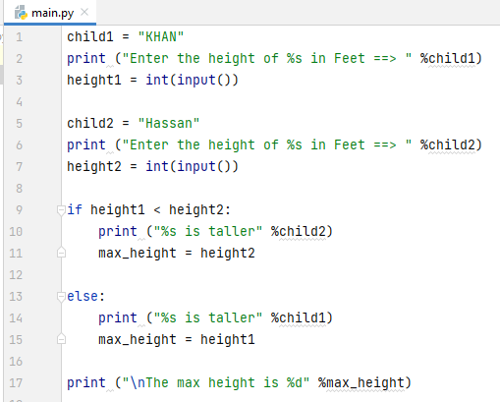

child1 = "KHAN"  
print ("Enter the height of %s in Feet ==> " %child1)  
height1 = int(input())  
  
child2 = "Hassan"  
print ("Enter the height of %s in Feet ==> " %child2)  
height2 = int(input())  
  
if height1 < height2:  
 print ("%s is taller" %child2)  
 max_height = height2  
  
else:  
 print ("%s is taller" %child1)  
 max_height = height1  
  
print ("\nThe max height is %d" %max_height)

**Task 5**

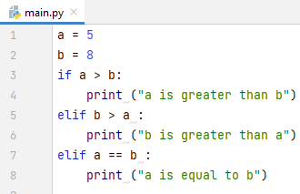

a = 5  
b = 8  
if a > b:  
 print ("a is greater than b")  
elif b > a :  
 print ("b is greater than a")  
elif a == b :  
 print ("a is equal to b")

Note! Python uses "elif" not "elseif" like many other programming languages do.

**Task 6**

**Calculating Grade of Student**

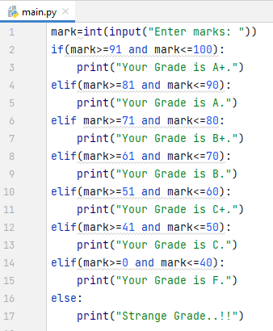

mark=int(input("Enter marks: "))  
if(mark>=91 and mark<=100):  
 print("Your Grade is A+.")  
elif(mark>=81 and mark<=90):  
 print("Your Grade is A.")  
elif mark>=71 and mark<=80:  
 print("Your Grade is B+.")  
elif(mark>=61 and mark<=70):  
 print("Your Grade is B.")  
elif(mark>=51 and mark<=60):  
 print("Your Grade is C+.")  
elif(mark>=41 and mark<=50):  
 print("Your Grade is C.")  
elif(mark>=0 and mark<=40):  
 print("Your Grade is F.")  
else:  
 print("Strange Grade..!!")

**LAB ASSIGNMENT 1**

Write a program to perform Mathematical Operations like (+),(-), (*) & (/).

1. Your program will take **two** input numbers from user and required operation from user (For example your Resource Person) via user inputs and perform the required operation on those numbers.
2. Your program will show the variable name first then its stored value, and then the answer of specific operation.